September 21, 2006

Dear Sirs/Madam,

Kindly refer to the discussions we had during the meeting held at Pune on 28th August, 2006 regarding residue monitoring plan for the 2007 grape season. As discussed and agreed to by all, we are in the process of modifying the RMP document to include Agmark inspection to be carried out by the laboratories, based on which the Agmark office would issue the certificate of Agmark grading. This procedure will also be web based. As soon as the document as well as the software is ready, these would be circulated and a demonstration of the web-based system would again be presented at different places for the benefit of all farmers, exporters, laboratories, state govt. officials, Agmark officials, etc. In so far as the laboratories are concerned, a few orientation and training programmes would be organized for them in the month of December, 06 & January, 07 to prepare them for the Agmark inspection.

During the meeting, it was also agreed that the farm registration once carried out would be valid for three years, but, would need to be renewed only on the basis of required documentation. It was agreed that the State Govts. would not charge any fee for the renewal process. However, this renewal as well as any new registration would need to be carried out during the web based system, which has been hosted on the website. An explanation to the procedure is enclosed for your ready reference. It is recommended that the farmers may initiate action for registration/renewal of registration of their farms up to the plot level as soon as possible.

In case you need any further clarifications please do not hesitate to contact us.

With regards,

S. Dave
Director - APEDA

Online Updation of Registered Farms / Renewal of Farms by State Govt. Agency.

for Export of Fresh Grapes to European Union.

How to access Online Registration Module?

Either through the URL http://www.apeda.com/registration

(Or)

Use the option link provided under the Online Facilities at http://www.apeda.com with the name “Farm Registration”

How to login to Online Registration Module?

State Govt.Agencies user need to login with the same USER ID and PASSWORD provided by APEDA

How to Register New Farm(s)/Plot(s) for 2006 season?

After logging into the online system, use the menu option /link “New Registration” to register New Farm(s) for the new season (i.e. 2006) which has not been registered last season.

How to Renew Farm(s)/Plot(s) for 2006 season?

In case of renewal of plots, which has been registered last season, use “Renewal of Registered Plot(s)” option. You need to provide the 12 digits Farm Reg. No. Of the Plot to be renewed. (See Fig-1)

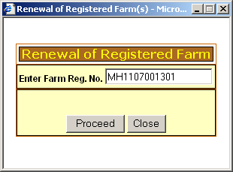

(Fig-1)

Once clicked on Proceed, the system will automatically fetch the details of the Plot and display it. (See Fig-2)
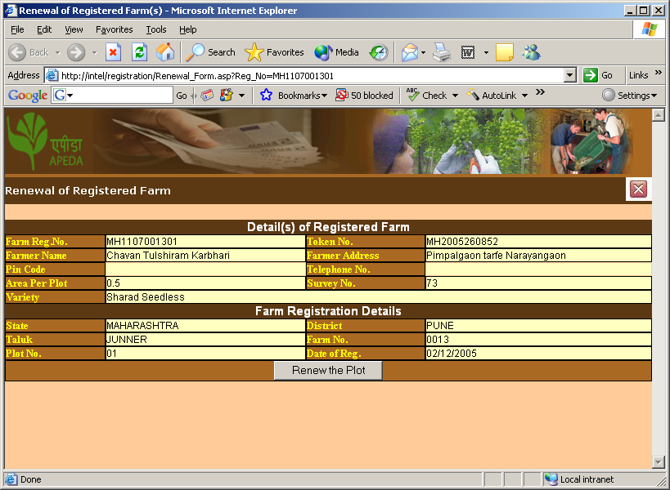
(Fig-2)
To renew the Plot, click on “Renew the Plot”.

The online system will display the following message on successful renewal
(See Fig –3)
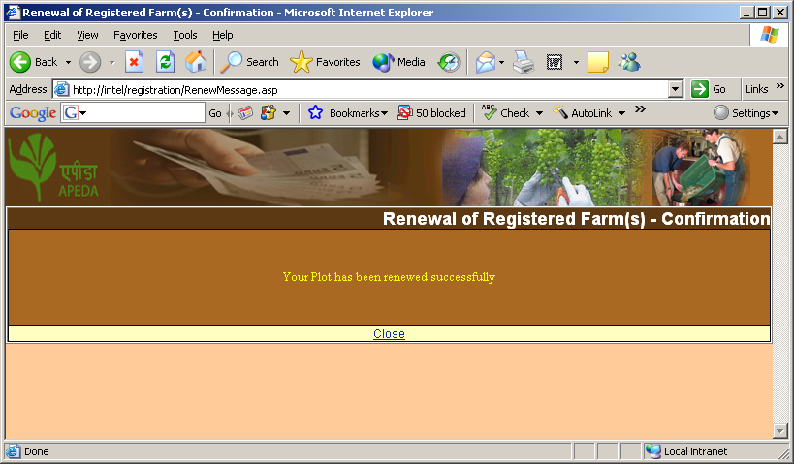
How to issue Certificate to Farmers/Exporters on Renewal?

On successful renewal, in the home page the system displays date wise registered / renewed Plot(s).

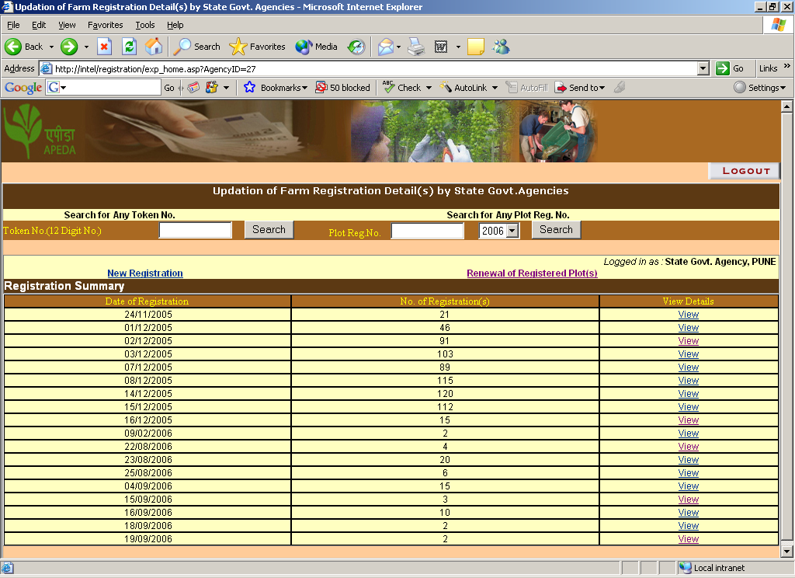

When clicked on View option, the system will display the individual plots either renewed/registered this season.

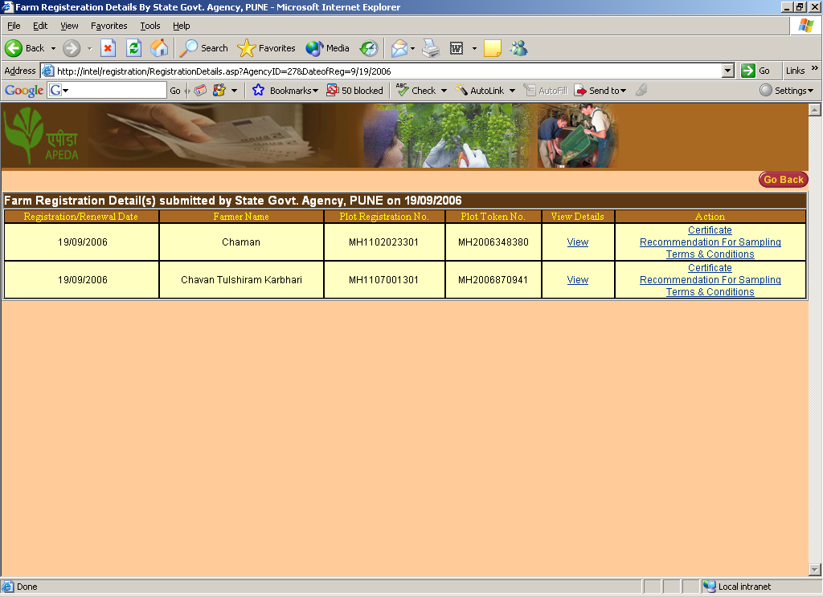

Using the Certificate option the SGA official can issue certificate to farmer/exporter.

