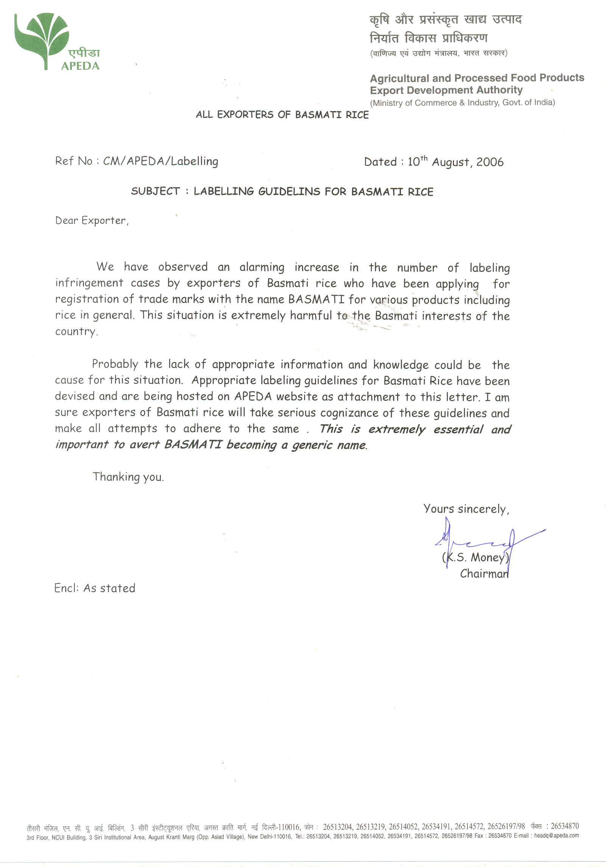

GUIDELINES FOR USE OF
THE GEOGRPHICAL INDICATION BASMATI IN INDIA

APEDA is an autonomous statutory authority, sponsored by the Ministry of Commerce, Government of India to promote agricultural and processed food products from India. APEDA’s authority includes representing the interests of Indian individuals and companies related to the growing, processing and export of agricultural produce, including BASMATI rice. In this context, APEDA has the authority to control the manner, extent and context of use of the name BASMATI in the course of trade and it would request the relevant trade to take the following precautions while seeking to register or use marks which may include the name BASMATI.

A. Use of BASMATI in Conjunction with a Trademark

An applicant may wish to register use of the mark ‘RED FORT BASMATI’ in respect of BASMATI rice. When seeking to register such a mark, the following conditions ought to be observed:

- That the rice sold/proposed to be sold under the mark is genuine BASMATI rice and the description of goods in the application should be limited to BASMATI rice only.

- As per the practice of the Trade Marks Registry, all descriptive matter in an application such as the word BASMATI would require to be disclaimed and no exclusive right would vest in the applicant. However, a disclaimer condition would not suffice since it is applicable to all descriptive and/or generic words and its inclusion in the application does not and cannot reasonably convey the information that the word disclaimed is a mark of regional origin

- If the mark RED FORT is used for other rice as well, the applicant must agree to a variation condition to the effect that, ‘as and when the mark is used for rice other than BASMATI rice, then the word BASMATI forming part of the mark would be replaced by the appropriate name of the other rice concerned’. In such event, the mark ‘RED FORT BASMATI rice’ for the goods ‘rice’ subject to such variation condition would be in order.

B. Use of BASMATI and Deceptive Variations thereof

BASMATI is a geographical indication used to denote a particular type of rice that comes from a specific geographical area (falling in the states of Punjab, Haryana, Uttar Pradesh and Uttaranchal in India and the state of Punjab in Pakistan), at the foothills of the Himalayas. BASMATI is a top-quality rice; famous for its slender, aromatic, long grain variety and its nutty taste and delicate texture. BASMATI possesses the above mentioned special properties deriving, inter alia, from its geographical origin and the agro-climatic growing conditions prevailing solely in the aforesaid region. The name, has, therefore, acquired special uniqueness, reputation and good will in the public mind when used in relation to rice produced in the aforesaid region so that the right to attach it to such rice forms part of the goodwill of all those who are duly associated with the said region, including growers, exporters, importers and traders of BASMATI rice. In brief, the right to use the name BASMATI is a public right as opposed to a trademark which is a private right. No one trader or person can claim exclusive rights to use of the name BASMATI.

Bearing the above principles in mind, no person can adopt, use or register marks which consist of the name BASMATI alone or any deceptive variations thereof.

C. Use of BASMATI in Respect of Dissimilar Goods and Services

Besides the restriction/prohibition of adoption and use of the name BASMATI as a trademark for rice and rice products, there is a further aspect of concern against any attempts to use the name in respect of dissimilar goods and services. Such use dilutes the significance of BASMATI as a geographical indication and should be not be allowed.

D. Use of BASMATI as part of corporate name/trading style/domain name

APEDA would request all those trading in Basmati rice not to use the word BASMATI as part of their respective corporate names/trading styles/domain name for the reasons:
- the permission to use BASMATI is limited only to describe the product sold in the market;
- use of Basmati to denote a particular company would lessen the mark’s ability to function as an indication of geographic origin, particularly when the corporate name/trading style containing the word Basmati would be forming part of the product packaging viewable to the end user;
- once the company becomes established, there would be nothing preventing it from selling rice from regions other than the Basmati growing region in India and Pakistan under its corporate name/trading style, thereby directly misleading consumers as to origin and composition of the rice being sold. Please note that such use would amount to a false trade description within the meaning of the Trade Marks Act, 1999 and the Geographical Indication of Goods (Registration and Protection) Act, 1999.

